Test # 298
Instrument Name Consistometer
Instrument Type Consistometer
Test Start 10/05/01 11:21
Test Stop 3:05:58
Well ID # 5652/2
Customer URAY
Cement Class G
Additives 12%MS+1.0%CFL-110+Dfmr
Cement Mfr DYKERHOFF
BHCT 65
BHST 85
Density 1500
Fluid Loss 65cc/30min
Job Type 146 MM CSG
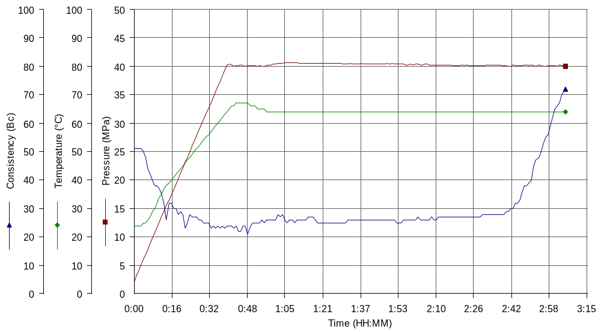
Comments MPa: 40(40min); T: 65(40min), Kogalym cement, tap water, dry blend Cem+MS, premix CFL-110, H=2900m

